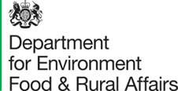

Defra Threat Modelling using STRIDE Framework and Microsoft tooling Guardrails
Date: October 2024
Version: 0.1

We are the Department for Environment, Food and Rural Affairs. We’re responsible for improving and protecting the environment, growing the green economy, sustaining thriving rural communities and supporting our world-class food, farming and fishing industries.
We work closely with our 33 agencies and arm’s length bodies on our ambition to make our air purer, our water cleaner, our land greener and our food more sustainable. Our mission is to restore and enhance the environment for the next generation, and to leave the environment in a better state than we found it.


© Crown copyright 2022
This information is licensed under the Open Government Licence v3.0. To view this licence, visit www.nationalarchives.gov.uk/doc/open-government-licence/
This publication is available at www.gov.uk/government/publications
Any enquiries regarding this publication should be sent to us at
[insert contact details]
PB [insert PB number. Not needed for consultation documents]
www.gov.uk/defra

Document Control

Change Record
Date | Author(s) | Version | Reference
11/10/2022 | Earl Opong | 0.1 | Initial document

Distribution and Review
Version No. | Date of distribution | Name / Group

Table of contents

Document Control 3
Introduction and Instructions 4
Introduction to Threat modelling guardrail 4
Instructions 4
What is Threat modelling: 5
The STRIDE framework 6
Threat modelling in a nutshell is: 10
Effective Threat Modell Engagements 12
Output from Threat Modelling 12
Training materials 12
Appendix A – Extra Mitigation information to consider 13
Appendix B – CIS V8 Controls mapped on to MITRE ATT&CK 14

Introduction and Instructions

Introduction to Threat modelling guardrail
The Defra Threat Modelling using STRIDE Framework and Microsoft tooling guardrail is to provide a consistent security threat modelling scope and tooling to Threat model in Defra. Due to Secure by Design (SbD) it is expected that Threat modelling for every project, software, system and service is done to show adherence to SbD. It will also provide insight in the security and cyber preparedness.
Also, will provide upfront security guidance for the implementation of every project, software and service which will allow security assessment to be much more detailed.

Instructions
The guardrails have been created for anyone that wishes to do thereat modelling within Defra. The framework and tooling must be adhered to if developing or implementing a threat model for purpose of usage within Defra.
All threat models that have not been done by the Security Architects or Information Assurance team must be reviewed and signed off my them. This is to ensure that all consideration pertaining to Defra estate have been covered from a security viewpoint that align to expectations.
Support with the reviewing or creation of Threat models can be requested from security.clinic@defra.gov.uk
Support with the completion of the Assurance Pack and Threat model can be requested from security.team@defra.gov.uk

What is Threat modelling:
Threat Modelling is about identify, prioritise and mitigate threats to an implementation. Using threat modelling provides the required information and techniques to model and analyse software, technology systems and services; understand how they could be attacked by a threat actor or otherwise be impacted; and identify any measures or controls to manage the risk posed by an attack or other types of impacts that could promote a technical failure across a system or service.
It is the understanding of Who, What, When, Why and How security questions, in relation to the project, software, system and service being assessed.
WHO:
Building the threat model
- Security Architect (SA)
- Security Assurance Team (SAt)
- Solution architect and Software developer (both will have to be reviewed by SA and SAt)
- Customer takes delivery of the threat model

What:
- Consider documentation and discussion of security
- Threat model documentation and tooling
  - The product entirety
  - The security-relevant features
  - The attack surface
- Assurance that the modelling has been done well

WHY:
- Allow you to be predictable and effectively find security issues early in the process
- Because attacker thinks differently (help to eliminate creator blind spots and a fresh perspective)

How:
- This is the main aspect of the Defra Threat Modelling; as different threats affect each type of element and have different security impacts on the system, service and organisation. To ensure there is consistency the framework must be the same as well as tooling.
- To deliver the “How”, Defra is using STRIDE framework and Microsoft threat modelling tooling.

The STRIDE framework
The STRIDE framework is used to identify the different threats but is not the only one. This has been chosen as it is the recommended framework for Government departments. Secure by Design has also referenced it for performing threat modelling (Performing threat modelling - UK Government Security - Beta)

What is STRIDE??
The table below explains the acronym of STRIDE and how they relate to Confidentiality, Integrity, and Availability (CIA triad) as well as Authentication, Authorization, and Accounting (Triple AAA) in cyber security:
Threats | Description | Security Control
Spoofing | Involves illegally accessing and then using another user's authentication information, such as username and password.  - How do we know who is sending us data?  - Do we authenticate users / devices?  - What data can users / devices submit?  - Can someone pretend to be someone else?  - Do we authenticate, if so, is it only at the system boundary?  - How well do we protect sensitive credentials on systems? | Authentication
Tampering | Involves the malicious modification of data with an intent to maliciously change or modify persistent data, such as records in a database, and the alteration of data in transit between two computers over an open network, such as the Internet.  Examples include unauthorized changes made to persistent data, such as that held in a database, and the alteration of data as it flows between two computers over an open network, such as the Internet  - Can someone modify what they submit? For example: is the integrity of data validated using hashes, message authentication codes, or digital signatures?  - Is it understood what unique properties each of the three above controls offer?  - Can someone break a trust boundary and cause changes? For example: are inputs validated before being processed? | Integrity
Repudiation | Associated with users who deny performing an action without other parties having any way to prove otherwise. For example, a user performs an illegal operation in a system that lacks the ability to trace the prohibited operations. Non-Repudiation refers to the ability of a system to counter repudiation threats. Also is accountability of the action being captured.  Another example, a user who purchases an item might have to sign for the item upon receipt. The vendor can then use the signed receipt as evidence that the user did receive the package.  - Can an action be associated to a unique identity? For instance, can someone or something perform an action and deny that it was them who performed it? | Non-Repudiation
Information Disclosure | Involves the exposure of information to individuals who are not supposed to have access to it, read a file that one was not granted access to, or to read data in transit which was supposed to be protected.  - Can others access information they should not have access to? For example: is data communicated in an unencrypted form?  - Does it utilise weak encryption or is the handling of cryptographic material, such as keys or the data from which keys are derived, poor?  - When someone change roles or leaves an organisation; is their access removed? | Confidentiality
Denial of Service | Denial of service (DoS) attacks deny service to valid users such as by making a web server temporarily unavailable or unusable. Note there are a few types of DoS attacks: Volumetric, Buffer Overflow, Flood, Protocol, Application Layer and Cloud-based attacks  - Can someone affect a system to degrade the ability of others to use it? For example: how well protected is the system from an internet-based denial of service?  - How resilient is the IoT network to radio frequency jamming?  - Are system inputs validated to ensure that a maliciously crafted input cannot cause the application layer to become unresponsive? | Availability
Elevation of Privilege | An unprivileged user gains privileged access and thereby has sufficient access to compromise or destroy the entire system. The intent is to gain privileged access to resources in order to gain unauthorized access to information or to compromise a system.  - Can an unprivileged user/process gain access beyond their established permissions?  - Gain increased capabilities without proper authorization (e.g. login into a system/service a standard user and then being able to change you profile to administrator to install a product) | Authorisation

How does the different threats from STRIDE affect the element types/object used in threat modelling is displayed in the table below:
Threat modelling Elements | S | T | R | I | D | E
External Entity | X |  | X
Process | X | X | X | X | X | X
Data Store |  | X | O | X | X
Data Flow |  | X |  | X | X

Based on the table above these are the rules:
- Apply the relevant part of STRIDE to the individual elements
- For Process all of STRIDE can have impact
- For Data store and Data flow: TID
- If the Data store has logs stored in it: TID + R
- For External entity: SR
- For Data flow inside a process: Don’t worry about T, I, or D
- Always number your thing/items to ensure it easy to understand the flow and being able to reference any part of the diagram.

Example of a Threat Model diagram:
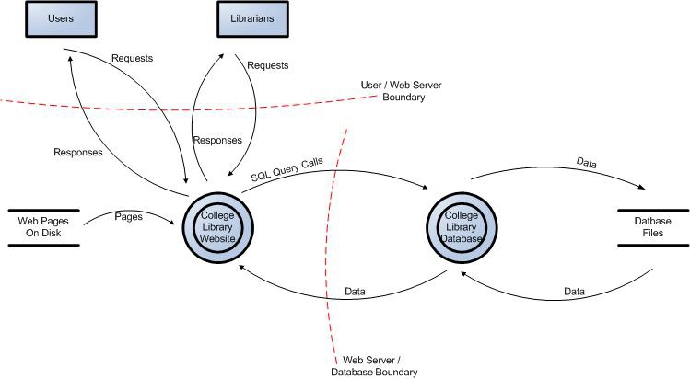

The diagram above depicts 2 boundary lines in red, 2 data sources (webpages on disk and database files), 2 external entities (users, Librarians), 2 processes and 9 data flows (pointing in the direction of flow)
Notation element | Reference | Examples
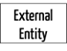 | External entity | People (e.g., users), systems (e.g. devices), cloud services, browsers
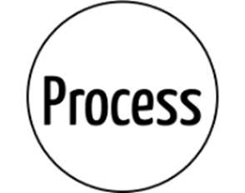 | Process | DDL, exe(D)COM, web service, virtual machine, threat
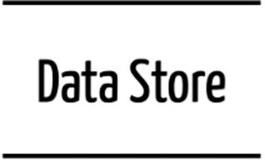 | Data store | File, database, registry, cache, cookie
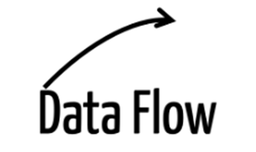 | Data flow | http request or response, remote procedure call, UDP communication
 | Trust boundary (indicate that within are trusted processes and data stores, but what is outside you do not trust) | Device boundary, process boundary

**Note due to no numeration it can be quite difficult to explain the threat model from the diagram as well as reference aspects of it in other documents

Threat modelling in a nutshell is:
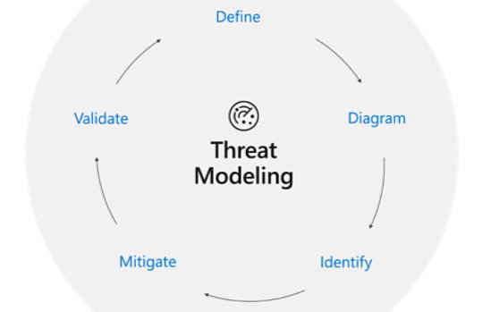
Image used is from: Microsoft Security Development Lifecycle Threat Modelling (Note Installation of the tooling might not be possible for certain Defra accounts. Please contact: security.clinic@defra.gov.uk or request via myIT service)

There are five major threat modelling steps:
1) Defining security requirements.
2) Creating an application/solution/service/system diagram.
3) Identifying threats.
4) Mitigating threats.
5) Validating that threats have been mitigated.
Threat modelling should be part of your routine solution, development and security lifecycle to enable you to progressively refine your threat model and further reduce risk across the organisation.

Details of the 5 modelling steps:
- Defining security requirements:
- This is where you should consider Threat Actors and Capabilities –as documented in the Defra security information assurance pack
- Threat Vectors – the STRIDE threat vector set

- Creating an application/solution/service/system diagram.
- This is using the tooling to create the diagram
- The tooling used Data Flow Diagrams (DFD)
- Elements that are used in the diagrams: process, data stores, dataflow, trust boundaries and external entities
- If possible, create diagrams per scenarios may be helpful
- Enumerate assumptions and dependencies

- Identifying threats.
- User and System Personas – are the roles and interfaces used and exposed by the solution (interactive user personas and API system personas) and as documented by the solution / security architect in the solution design
- Solution architecture – describing system components, data stores, data flows, domain boundaries and component / network interfaces will be as documented by the solution / security architect in the solution design
- Controls Taxonomy – from CIS v8 or Defra control taxonomy, SbD guidelines / CSA etc. describing the control groupings and control details that mitigate the potential threat vectors
- Mitigating threats.
- To address and alleviate each problem/threat
- Protect customers/clients and organizations
- Design secure software, solution, systems and services
- Find problems/threats to fix, understand implications, bring awareness and take decisions
- Ways to address threat/problems:
  - Apply security standards and controls
  - Redesign to eliminate
  - Consider what similar software packages, solution, systems and services have implement to resolve similar issues
  - Consider lesson learnt and how they were resolved or not
  - Invent new mitigation options based on validation/acceptance
  - Accept vulnerability based on the business SRO/organisation risk acceptance
- Finally seek expert advice and do not assume

- Validating that threats have been mitigated.
- Validate the whole threat model
  - Does the diagram match the software packages, solution, systems and services design/diagram??
  - Are the threats enumerated??
  - Have the minimum STRIDE elements been captured and their interception with the trust boundaries captured correctly??
  - Has Security Architect/Tester/QA/Expert reviewed the model??
  - Has each threat been mitigated??
  - Are the mitigations the right ones for the software packages, solutions, systems and services?? (consider data, cost, internal or external exposure and practicalities)
  - Have the mitigations been applied rightly??

- Validate the threats captured:
  - Have the attack vectors been described clearly??
  - Is there enough specific context?? (try not to go overboard with information; less and specific/precise is great)
  - Capture impact information
- Validate the mitigation captured:
  - Have the mitigations provided aligned with a threat??
  - Is the description of the mitigation clear??
  - Are the mitigations prescribing an actual mitigation??

- Validate dependencies and impacts considered for threat modelling??
- Validate assumptions considered for threat modelling??

- Has a final check been done before the final security review??

Effective Threat Model Engagements
- Develop draft threat models before meeting based on information provided upfront by the project
- Begin with the DFD walkthrough to start the discussions with a focus on area that are uncertain or require extra input.
- Identify most interesting elements, assets (if identified or any) and Entry point/trust boundaries
- Walk through STRIDE against the elements within the threat model
- Point out/focus of threat that cross elements/recure (might have to discuss redesign or consider other options)

Output from Threat Modelling
After the initial discussion/meeting and ensuring the identified threat vectors have been recognised as well as documented correctly. The information must be mapped in the Information Assurance pack and Secure by Design assessment document.
If further security monitoring is required then an initial discussion with Defra SOC and CCoE team should be done.
Also, this must be tracked and ensured that there have been no changes which could have a security impact to the software packages, solution, systems and services.

Training materials
(Note Installation of the tooling might not be possible to certain Defra accounts. Please contact: security.clinic@defra.gov.uk or request via myIT service)
Training information:
Getting Started - Microsoft Threat Modeling Tool - Azure | Microsoft Learn
https://learn.microsoft.com/en-us/azure/security/develop/threat-modeling-tool
Extra training information: https://learn.microsoft.com/en-us/archive/msdn-magazine/2009/january/security-briefs-getting-started-with-the-sdl-threat-modeling-tool
Driver Security Guidance - Windows drivers | Microsoft Learn
GitHub - AzureArchitecture/threat-model-templates: Templates for the Microsoft Threat Modeling Tool

Appendix A – Extra Mitigation information to consider
Information in table below from : Mitigations - Microsoft Threat Modelling Tool - Azure | Microsoft Learn
Mitigation Category | Description
Auditing and Logging | Who did what and when? Auditing and logging refer to how your application records security-related events
Authentication | Who are you? Authentication is the process where an entity proves the identity of another entity, typically through credentials, such as a username and password
Authorization | What can you do? Authorization is how your application provides access controls for resources and operations
Communication Security | Who are you talking to? Communication Security ensures all communication done is as secure as possible
Configuration Management | Who does your application run as? Which databases does it connect to? How is your application administered? How are these settings secured? Configuration management refers to how your application handles these operational issues
Cryptography | How are you keeping secrets (confidentiality)? How are you tamper-proofing your data or libraries (integrity)? How are you providing seeds for random values that must be cryptographically strong? Cryptography refers to how your application enforces confidentiality and integrity
Exception Management | When a method call in your application fails, what does your application do? How much do you reveal? Do you return friendly error information to end users? Do you pass valuable exception information back to the caller? Does your application fail gracefully?
Input Validation | How do you know that the input your application receives is valid and safe? Input validation refers to how your application filters, scrubs, or rejects input before additional processing. Consider constraining input through entry points and encoding output through exit points. Do you trust data from sources such as databases and file shares?
Sensitive Data | How does your application handle sensitive data? Sensitive data refers to how your application handles any data that must be protected either in memory, over the network, or in persistent stores
Session Management | How does your application handle and protect user sessions? A session refers to a series of related interactions between a user and your Web application

Appendix B – CIS V8 Controls mapped on to MITRE ATT&CK
CIS controls are a general set of recommended practices for securing a wide range of systems and devices, cyber-attacks are known for exploiting what can be considered ‘poor cyber hygiene’ such as unpatched software, insecure configurations and outdated solutions. The CIS critical security controls are a set of prescriptive, prioritised and simplified security best practices for strengthening the cyber security posture.
Each control breaks down into measurable actions or safeguards that provide a simplified approach to defend against most MITRE ATT&CK sub techniques associated with malware, ransomware and other cyber threats.
By utilising the CIS controls, you will be able to map MITRE to this and identify any areas of consideration for protective monitoring and align this with the Risk assessment to identify what the SOC should monitor for the system or service.
Link to a copy: Defra Architecture - Threat Modelling info

